## Introduction

The bike-sharing market in the United Kingdom is increasing year-on-year, with it expected to generate revenue of £47,410,000 in 2025 (https://www.statista.com/outlook/mmo/shared-mobility/bike-sharing/united-kingdom). As such, it is no surprise that the industry has garnered the attention of numerous businesses. Thus, it is clear that understanding the trends and intricacies of the bike-sharing market is of clear value to many.

In this project, I will aim to uncover trends and patterns within data collected from bike rental data within London. The main factors we will observe are: **Season**, **Weather,** **Temperature**, and **Comparisons between Holidays and Weekends**. We will visualize this data in **Power BI**.

The data is sourced from: <https://www.kaggle.com/datasets/hmavrodiev/london-bike-sharing-dataset/data>.

*Powered by TfL Open Data - Contains OS data © Crown copyright and database rights 2016' and Geomni UK Map data © and database rights [2019].*

## Goals

Based on our dataset, we will aim to:

1. Display a breakdown of **rental count** against **season** and **weather** data.
2. Investigate any correlation between **rental count** and **temperature** data.
3. Investigate any connection between **rental count** and **holiday** / **weekend** data.
4. Display key numerical data clearly.
5. Allow for **user input** to adjust the data on the dashboard in real-time.

## Visuals

We created visuals based on the goals highlighted above. The key aim was to have data be clearly readable by the user, whilst allowing users to interact with the dashboard to view the data they want to see.

**Visual 1: Rental Distribution by Season and Weather Donut Charts**

These display the distribution of *rental count* based on *season* and by *weather*. The visual was designed to look like bike tyres as a method of linking the visual to the topic. The user can select a section of the donut chart to filter all visuals on the dashboard by that *season* or *weather*.

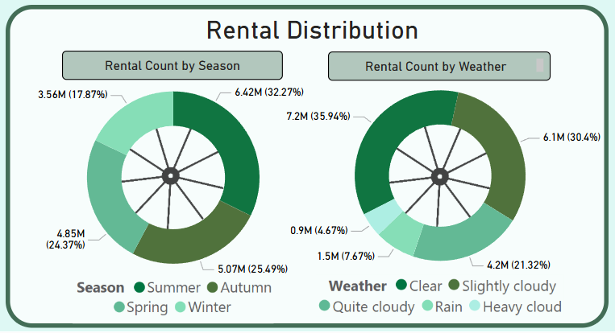

**Visual 2: Rental Trends Over Time Line Chart**

This visual displays *rental count* by *date* and by *time of day*. The user can swap between these using the incorporated button at the bottom of the visual. The user can also select a specific point on the chart to filter the dashboard by that selection.

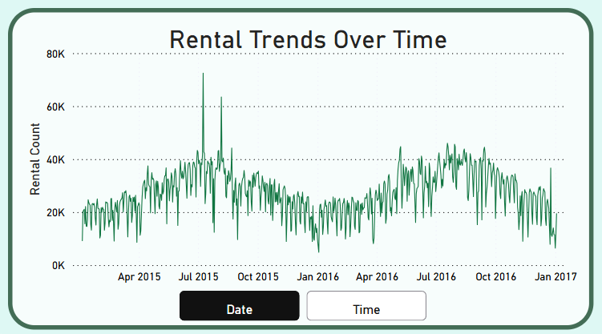

**Visual 3: Rental Distribution by Temperature**

This visual displays *rental count* by *temperature* and *feels like temperature*. The user can swap between these using the incorporated button at the bottom of the visual. There is a linear trendline on the visual to clearly show the trends within the data.

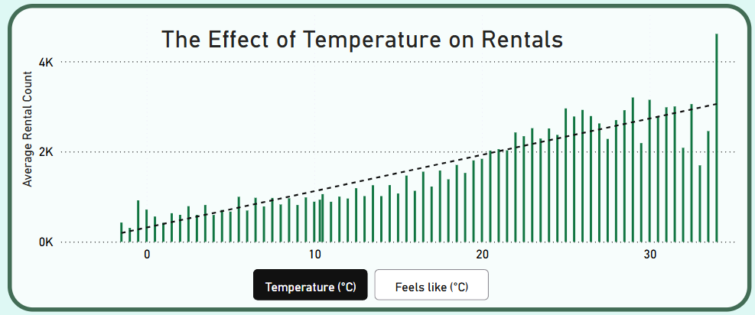

**Visual 4: Holiday and Weekend Rental Distribution Bar Chart**

This visual displays *rental count* based on whether or not it is a *weekday* or the *weekend*, or a *holiday* or *not a holiday*. The user can swap between these using the incorporated button at the bottom of the visual

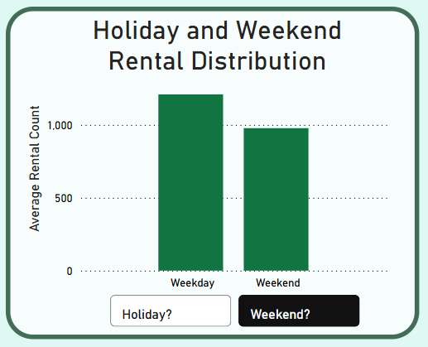

**Visual 5: Key Statistic Cards**

These 4 card visuals are located on the right-hand side of the dashboard, and display some key statistics that the user will want to know. These are unaffected by filters applied to the dashboard from other visuals, ensuring that key information remains on display.

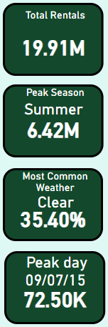

**Filter: Date Selection Slicer**

This slicer allows the user to examine data between two different dates within the data. This effects all visuals on the dashboard, including the *key statistic cards*. The *reset page* button on this slicer resets the dashboard to its default state.

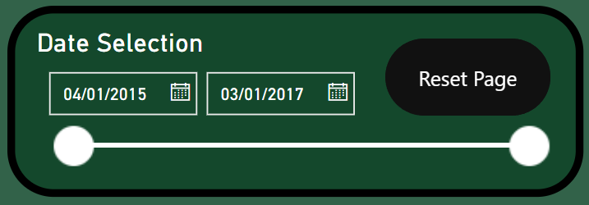

## Layout

The dashboard was laid out so that all interactive elements are situated together around the central area of the canvas, with other visual elements being situated around the outside. This is so that the user’s attention is focused on the data-centric part of the dashboard.

## Findings

The dashboard can be used to make some conclusions on our dataset:

* *Rental count* is higher in better weather conditions. We can see this in the *Rental Distribution* donut charts where 32% of rentals are made during Summer compared to 17% in Winter, and 35% of rentals made during clear/sunny weather conditions.
* *Rental count* and *Temperature* have a positive correlation. We can see this in the *The Effect of Temperature on Rentals* line chart which showcases a positive linear trendline.
* *Rental count* is linked to the seasonal cycle. The *Rental Trends Over Time* line chart shows clear peaks in Summer months and troughs in Winter months.
* There could be links between *Rental count* and *Time*. When filtering the dashboard to view only *Weekday* data, *Rental Count* peaks at 08:00 and 17:00, very common working hours. When we then look at *Weekend* data, this trend disappears. This could be worth further investigation to companies working in the sector.
* *Holidays* have a lower rental count than *non-holidays*.

## Limitations of the Project

One of the large issues with this project is the geographical scope of our data. As all of our data is collected from London, it is difficult to apply this to other locations – Cities in the UK have a plethora of different levels of bike infrastructure available. Given that London is the capital city of England, it would not be surprising if it had better infrastructure than elsewhere. Collecting data from several different locations would make any conclusions more applicable to other locations.